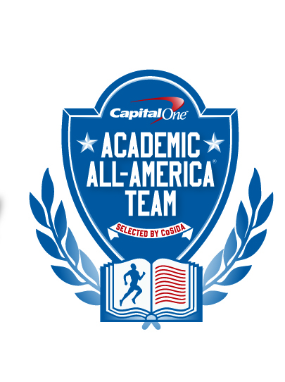
Capital One Academic All-America® TEAM

Selected by CoSIDA

FOR RELEASE: Tuesday, May 21 – 12 noon (EDT)

MACKENZIE GRIFFIN OF JOHN CARROLL TOPS CAPITAL ONE ACADEMIC ALL-AMERICA® DIVISION III SOFTBALL TEAM
Please visit the Capital One Academic All-America® website http://www.capitaloneacademicallamerica.com/
TOWSON, Md. – Senior catcher Mackenzie Griffin of John Carroll University leads the 2013 Capital One Academic All-America® Division III Softball Team, as selected by the College Sports Information Directors of America (CoSIDA).
A communications major with a 3.72 G.P.A., Griffin has been chosen as the Capital One Division III Academic All-America® of the Year award winner for softball.
The Capital One Division III Academic All-America® program is being financially supported by the NCAA Division III national governance structures, to assist CoSIDA with handling the awards fulfillment aspects for the 2012-13 and Division III Academic All-America® teams program.
One of 11 first time selections on this year’s Capital One Academic All-America® Division III Softball first team, Griffin is a 2013 National Fastpitch Coaches Association (NFCA) first-team All-Central Region selection. A native of Lake Oswego, Oregon, she is a three-time All-Ohio Athletic Conference honoree, earning first team honors this season.
Griffin led the Blue Streaks to a pair of NCAA Division III regional appearances. As a senior, she set a John Carroll single season record with a .548 batting average as she led the OAC in hitting. She also hit 20 doubles with three homers and 43 RBI’s while leading her team to a 26-13 record.
She finished her career with a .390 batting average while setting school records with 165 games played, 126 runs scored and 199 base hits.
Senior designated player Kaaren Hatlen of Pacific Lutheran is the only repeat selection on this year’s Capital One Academic All-America® Division III softball first team. A mathematics major with a 3.95 G.P.A., she was a first team Academic All-America® pick for the second straight year. A native of Woodinville, Wash., she batted .386 with 53 RBI’s and hit 12 home runs. A three-time first team All-Northwest Conference pick, she is a two-time second team NFCA All-West Region pick.
Seniors Jeramie Barletta of Drew and Devan Boggs of Capital join Gillian McCarthy of Rensselaer Polytechnic, and Harmony Palmer of Claremont-Mudd-Scripps as the infielders on the first team. Junior pitchers Amanda Kardys of Emory and Alexandria Hill of Montclair State have also been named to the first team, along with senior outfielders Bri Dorale of Augsburg, Alison Gray of Wisconsin-Stout, Stephanie Schell of Messiah and Laura Tjepkema of Hope.
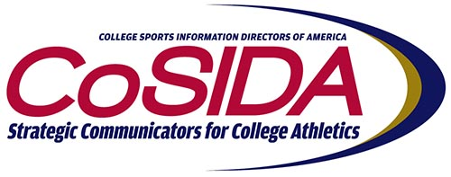
A political science major with a 3.97 G.P.A., Barletta led the Rangers in hitting with a .407 batting average. She also led Drew with 44 base hits, a .467 on-base percentage, and 56 total bases. A native of Madison, N.J., she was a first team All-Landmark Conference first team selection and a three-time Landmark Conference Academic Honor Roll pick. She played in 140 straight games after starting in all 36 games this season.
more-
Griffin Leads Capital One Academic All-America® Division III Softball Team– page 2
An exercise science major (pre-physical therapy) with a 3.53 G.P.A., Boggs led Capital to the OAC regular season title and the NCAA Tournament for the fourth time in school history. A native of West Jefferson, Ohio, she was the 2013 OAC Player of the Year and a four-time All-OAC selection. She was named first team All-OAC three times. She was a four-time NFCA All-Central Region selection and earned third team NFCA All-America honors last year. Boggs led the OAC and Crusaders with 53 RBI’s and 14 home runs. She was second on the team with a .488 batting average.
A business and management and communications double major with a 3.93 G.P.A., McCarthy was a second team Capital One Academic All-America® Division III honoree last year. McCarthy is a four-time unanimous All-Liberty League first team choice and was the Co-Player of the Year in 2013. A third team NFCA All-Northeast Region selection she was a three-time Liberty League All Academic pick. A native of Worthington, Ohio, McCarthy batted .435 for RPI with nine doubles, one triple and seven home runs, 23 runs scored and 36 RBI’s.
An economics and accounting double major with a 3.88 G.P.A., Palmer was the lone Southern California Intercollegiate Athletic Conference (SCIAC) player to be named to the Capital One Academic All-America® Division III first team. A native of Oceanside, Cal., Palmer led the Athenas and the SCIAC in batting average (.482) and stolen bases with 25. She is a first team All-SCIAC pick and a NFCA All-West Region first team selection
A biology and psychology double major with a 3.80 G.P.A., Kardys was an NFCA first team All-Atlantic Region selection and also earned All-University Athletic Association honors for Emory. A native of Union, N.J., Kardys was the ace of the Eagles' pitching staff, and had an outstanding record of 25-5 with a 1.60 E.R.A .and 100 strikeouts. Kardys opened the 2013 season by not allowing an earned run in her first 59 innings of action.
A psychology major with a 3.55 G.P.A., Hill was a Capital One Academic All-America® Division III third team pick as a junior and senior. Hill was instrumental in leading the Red Hawks to their second consecutive NCAA Division Softball Championships appearance. She had a 37-3 record with a 0.58 E.R.A. in 45 appearances this season with four saves, 16 shutouts and 413 strikeouts. A native of Parsippany, N.J., Hill was the New Jersey Athletic Conference (NJAC) Pitcher of the Year three times and earned All-NJAC first team notice three times. Named as the Most Outstanding Player in the NCAA regionals twice, she led Montclair State to a 46-5 record. A three-time NFCA first team All-East Region selection, she was the NJAC Female of the Year in 2012. She is the Montclair State record holder for career wins (86), strikeouts (932) and shutouts (44).
A marketing major with a 3.90 G.P.A., Dorale had a career year for Augsburg as she set school records with a .523 batting average and 67 hits. Dorale also had 25 stolen bases and hit safely in 34 of her 39 games. A native of Ramsey, Minn., Dorale is a two-time All-Minnesota Intercollegiate Athletic Conference (MIAC) selection and earned first team NFCA All-Midwest Region notice.
A packaging major with a perfect 4.00 G.PA, Gray was named to the Capital One Academic All-America® Division III second team last season. A native of St. Cloud, Minn., she is a seven-time recipient of the UW-Stout Chancellor's Award for Academic Excellence. She is also a three-time NFCA Scholar-Athlete and a three-time member of the WIAC Scholastic Honor Roll. As a senior, Gray batted .359 with a team-leading nine home runs and 31 RBI’s.
A molecular biology major with a 3.96 G.P.A., Schell batted .414 with 16 doubles for Messiah. Schell also had 29 RBI’s and had 46 putouts in the outfield without an error. A native of Jarrettsville, Md., she was the Commonwealth Player of the Year as a senior. A four-time All-Commonwealth selection, she was the Middle Atlantic Conference (MAC) Scholar-Athlete of the Year for softball.
- more -
Griffin Leads Capital One Academic All-America® Division III Softball Team– page 3
A special education major with a perfect 4.00 G.P.A., Tjepkema is the fourth outfielder on the first team due to a tie in the voting. A third team Capital One Academic All-America® Division III selection last year, she is a two-time All-Michigan Intercollegiate Athletic Association (MIAA) selection. A native of Dorr, Mich., Tjepkema led Hope in batting with a .380 average, 46 hits, eight doubles and 31 RBI’s. She batted .358 over her career and finished third all-time with 109 RBI’s, fifth in total hits (162), and sixth in runs scored (87).
The 12 members of the Capital One Academic All-America® Division III softball first team maintain an average G.P.A. of 3.85, while two of the members have a perfect 4.00 G.P.A.
About Capital One
Capital One Financial Corporation (www.capitalone.com) is a financial holding company whose subsidiaries, which include Capital One, N.A. and Capital One Bank (USA), N. A., had $122.2 billion in deposits and $197.5 billion in total assets outstanding as of December 31, 2010. Headquartered in McLean, Virginia, Capital One offers a broad spectrum of financial products and services to consumers, small businesses and commercial clients. Capital One, N.A. has approximately 1,000 branch locations primarily in New York, New Jersey, Texas, Louisiana, Maryland, Virginia and the District of Columbia. A Fortune 500 company, Capital One trades on the New York Stock Exchange under the symbol "COF" and is included in the S&P 100 index.
Capital One, an NCAA Corporate Champion, began its affiliation with college sports with the sponsorship of the 2001 Capital One Florida Citrus Bowl (now the Capital One Bowl) and ESPN’s Capital One Bowl Week. In 2010, Capital One launched the Capital One Cup, a prestigious new program rewarding NCAA Division I athletics programs for their cumulative on-field performance across multiple men’s and women’s sports. In addition, Capital One sponsors the ABC College Football Halftime Report, Capital One All-America Mascot Team, all 88 NCAA Championships including the Division I Men’s and Women’s Basketball Championships, and numerous other collegiate athletics programs.
To be eligible for Academic All-America® consideration, a student-athlete must be a varsity starter or key reserve, maintain a cumulative G.P.A. of 3.30 on a scale of 4.00, have reached sophomore athletic and academic standings at his/her current institution and be nominated by his/her sports information director.
Since the program’s inception in 1952, CoSIDA has bestowed Academic All-America honors on more than 18,000 student-athletes in Divisions I, II, III and NAIA, covering all NCAA championship sports.
For more information about the Academic All-America® Teams program, please visit www.cosida.com.
FOR MORE INFORMATION:
Dan O’Connell, Towson University (doconnell@towson.edu) (410) 704-310
Academic All-America ® Vice-Chair for Publicity/Communications
Nick Minerd, Case Western Reserve University (nxm229@case.edu) (216) 368-6517
Academic All-America ® Coordinator of Publicity
Jeff Miller, Baldwin Wallace University (jeffmille@bw.edu) (440) 826-2780
Academic All-America ® Coordinator of Publicity
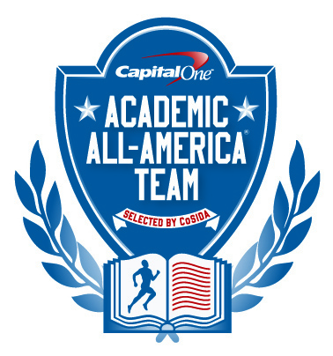
2013 Capital One
Academic All-America ®
Division III
Softball Team

Academic All-America of the Year: Mackenzie Griffin, John Carroll

FIRST TEAM
Pos. Name School Yr. Hometown G.P.A. Major
P Amanda Kardys Emory Jr. Union, N.J. 3.80 Biology and Psychology
P Alexandria Hill (3) Montclair State Jr. Parsippany, N.J. 3.55 Psychology
C Mackenzie Griffin John Carroll Sr. Lake Oswego, Ore. 3.72 Communications
INF Jeramie Barletta Drew Sr. Madison, N.J. 3.97 Political Science
INF Devan Boggs Capital Sr. West Jefferson, Ohio 3.53 Exercise Science (pre-PT)
INF Gillian McCarthy (2) Rensselaer Polytechnic Sr. Worthington, Ohio 3.93 Business, Mngmnt & Comm.
INF Harmony Palmer Claremont-Mudd-Scripps Sr. Oceanside, Calif. 3.88 Economics and Accounting
OF Bri Dorale Augsburg Sr. Ramsey, Minn. 3.90 Marketing
OF Alison Gray (2) Wisconsin-Stout Sr. St. Cloud, Minn. 4.00 Packaging
OF Stephanie Schell Messiah Sr. Jarrettsville, Md. 3.96 Molecular Biology
OF Laura Tjepkema (3) Hope Sr. Dorr, Mich. 4.00 Special Education
DP Kaaren Hatlen (1) Pacific Lutheran Sr. Woodinville, Wash. 3.95 Mathematics
SECOND TEAM
Pos. Name School Yr. Hometown G.P.A. Major
P Rachel Johnson Salisbury So. Preston, Md. 3.81 Biology
P Ashley Marshall Plattsburgh State Sr. Malone, N.Y. 3.71 Childhood Ed. (UG),Spec. Ed(G)
C Abby Flannagan Coe Jr. Manchester, Iowa 3.62 Biology, Pre-Med
INF Kimmy Hassel St.. Thomas (Minn.) Sr. Bloomington, Ill. 3.57 Middle, Secondary Educ.
INF Cora Jeffers Millikin Sr. Sherman, Ill. 3.98 Music Education-Instrumental
INF Megan Light Emory Jr. Atlanta, Ga. 3.96 Anthropology & Human Bio.
INF Jessica Van Galen Manhattanville Sr. Bedford Hills, N.Y. 3.78 Education / mathematics
OF Kristen Gromes Mount Union Sr. Navarre, Ohio 3.84 Engineering & art
OF Ashley Janssen Washington (Mo.) Sr. Lincoln, Neb. 3.87 Neuroscience
DP Kelsey Neal (3) Washington (Mo.) Jr. Miami, Okla. 3.87 Economics
THIRD TEAM
Pos. Name School Yr. Hometown G.P.A. Major
P Bree Fuller Trine So. Hubbardston, Mich. 3.88 Exercise Science
P Krystina Leazer Carthage Sr. Des Plaines, Ill. 3.53 Exercise & Sport Science
P Ali Sayre Heidelberg Sr. Sylvania, Ohio 4.00 Political Science
C Lya Swaner East Texas Baptist Sr. St. Paul, Texas 3.85 Chemistry and Biology
C Carol Brown Skidmore Sr. Seattle, Wash. 3.98 Mathematics
INF Kristen Beikirch Sage Colleges So. Brockport, N.Y. 3.91 Biology
INF Ashley Goettl (3) Wisconsin-River Falls Sr. North Mankato, Minn. 3.85 Journalism,Com. Stud.Pol.Sci.
INF Caitlin Lovend (3) Frostburg State Sr. Laurel, Md. 3.81 Athletic Training
INF Kelly McGrail (1) Wisconsin-Whitewater Jr. Tinley Park, Ill. 3.97 Special Education BSE
INF Holly Schell Immaculata Sr. Sewell, N.J. 3.98 Elementary, Special Ed.
OF Leah Alpert Mass. Inst. of Tech. Sr. Needham, Mass. 4.00 Comp. Science & Engineering
OF Meghin Palmer (1) Marywood Gr. Greencastle, Pa. 3.89 CSD Speech Pathology
OF Christina Smith Concordia (Tex.) Sr. Mesa, Ariz. 4.00 Biology
DP Lauren Goldfarb Wellesley Sr. Albuquerque, N.M. 3.55 Geosciences

(1) Capital One Academic All-America® first team in 2012
(2) Capital One Academic All-America® second team in 2012
(3) Capital One Academic All-America® third team in 2012

