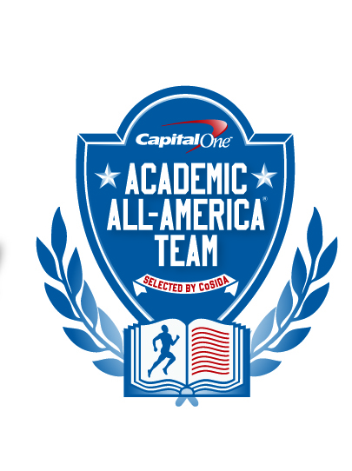

Capital One Academic All-America® Team

Selected by CoSIDA
FOR RELEASE: Wednesday, August 7, 2013 – 12 noon (EDT)
Please visit the Capital One Academic All-America® website
http://www.capitaloneacademicallamerica.com/
KARI DAUGHERTY OF ASHLAND NAMED AS CAPITAL ONE DIVISION II ACADEMIC ALL-AMERICA® OF THE YEAR
TOWSON, Md. – Senior Kari Daugherty of Ashland University, who led the Eagles to their first NCAA Division II women’s basketball national championship, has been named as the 2012-13 Capital One Division II Academic All-America® of the Year, as selected by the College Sports Information Directors of America (CoSIDA).
A middle childhood education major who graduated with a 3.97 G.P.A., Daugherty guided Ashland to a 70-3 record during her two seasons at the Ohio school.
The Capital One Division II Academic All-America® program is being financially supported by the NCAA Division II national governance structure to assist CoSIDA with handling the awards fulfillment aspects for the 2012-13 Division II Academic All-America® teams program.
“Wow – what an honor it is to receive an award like this,” said Daugherty. “In Division II, I know how so many athletes take pride in their athletic and academic success. To be honored with an award like this is special and meaningful. I know how hard people work to be successful academically and athletically.”
Named as the winner of the Division II Bulletin’s National Player of the Year award, Daugherty was the top scorer and rebounder for the Eagles while leading them to their first-ever national title. As a senior, she averaged 22.3 points and 13.7 rebounds per game with a .522 field goal percentage.
The third-leading scorer in Division II, she was the second-leading rebounder in the nation and topped Division II with 25 double-doubles. A two-time All-American first team selection, she was also named as the WBCA National Player of the Year.
Honored as the Great Lakes Intercollegiate Athletic Conference Player of the Year twice, the Fresno, Ohio native led Ashland to the national title with a record-setting performance. In six NCAA Tournament games, she scored 145 points with 85 rebounds. She posted a double-double in all six NCAA Tournament games while leading Ashland to a dominant performance in the post-season.
In the NCAA Tournament, Ashland had a 12.3-point average margin of victory in its six wins. Daugherty, who averaged 24.2 points and 14.2 rebounds per game, was named as the NCAA Division II Tournament’s Most Outstanding Player. In a 71-56 victory over Dowling in the national championship game, she scored 26 points with 12 rebounds.
Daugherty, who played at the University of Dayton for two years before transferring to Ashland, was also honored as the winner of the Division II Honda Sports Award in 2012 and 2013. She became the first student-athlete to win the award in two consecutive years.
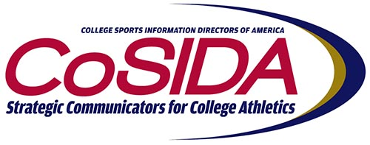
As a junior, she led Ashland to the national championship game by averaging 21.3 points and 14.1 rebounds per game. She was the top rebounder in the nation as a junior and set school records with 744 points and 492 rebounds. As a junior, she also set NCAA Tournament records with rebounds (95) and field goals made (56).
A 6-1 forward, Daugherty also set an NCAA record with 34 consecutive double-doubles.
The Capital One Division I Academic All-America® of the Year award winner will be named on Thursday, August 8.
About Capital One
Capital One Financial Corporation (www.capitalone.com) is a financial holding company whose subsidiaries, which include Capital One, N.A., Capital One Bank (USA), N. A., and ING Bank, fsb, had $216.5 billion in deposits and $294.5 billion in total assets outstanding as of March 31, 2012. Headquartered in McLean, Virginia, Capital One and ING Direct offer a broad spectrum of financial products and services to consumers, small businesses and commercial clients through a variety of channels.
Capital One, N.A. has approximately 1,000 branch locations primarily in New York, New Jersey, Texas, Louisiana, Maryland, Virginia and the District of Columbia. A Fortune 500 company, Capital One trades on the New York Stock Exchange under the symbol "COF" and is included in the S&P 100 index.
Capital One, an NCAA Corporate Champion, began its affiliation with college sports with the sponsorship of the 2001 Capital One Florida Citrus Bowl (now the Capital One Bowl) and ESPN’s Capital One Bowl Week. In addition, Capital One sponsors the ABC College Football Halftime Report, Capital One All-America Mascot team, Capital One Academic All-America® Program, and supports all 89 NCAA Championships including the Division I Men’s and Women’s Basketball Championships, and numerous other collegiate athletics programs.
To be eligible for Academic All-America® consideration, a student-athlete must be a varsity starter or key reserve, maintain a cumulative G.P.A. of 3.30 on a scale of 4.00, have reached sophomore athletic and academic standings at his/her current institution and be nominated by his/her sports information director.
Since the program’s inception in 1952, CoSIDA has bestowed Academic All-America honors on more than 20,000 student-athletes in Divisions I, II, III and NAIA, covering all NCAA championship sports.
For more information about the Academic All-America® Teams program, please visit www.cosida.com.
2012-2013 CAPITAL ONE SPORT-BY-SPORT DIVISION II ACADEMIC ALL-AMERICA® OF THE YEAR AWARD WINNERS

Name Sport Cl. Hometown Major, G.P.A.
Jennifer Costello, Missouri S&T Volleyball Sr. St. Louis, Mo. Chemical Engineering, 4.00
Kari Daugherty, Ashland W. Basketball Sr. Fresno, Ohio Middle Childhood Education, 3.97
Marc Hershberger, Metropolitan St. M. Soccer Sr. Westminster, Col. Management, Marketing, 3.91
Kristen Hixson, Grand Valley State W. Track, CC Jr. Remus, Mich. Finance, 3.96
Amy Madden, Southern Nazarene Softball Sr. Bethany, Okla. Biology-Chemistry, 4.00
Taylor Rakes, Tusculum Baseball Gr. Norcross, Ga. Economics & Int. Business, 4.00
Mark Rubin, Incarnate Word M. At Large Sr. Phoenix, Ariz. Biology, 3.98
Marcus Ruh, St. Leo’s M. Basketball Sr. Green Bay, Wis. Business Administration, 4.00
Dustin Vaughan, West Texas A&M Football Jr. Corpus Christi, Tex. Biology, 3.74
Brent Vogel, Central Missouri M. Track, CC Sr. Jefferson City, Mo. Biology, 3.74
Julie Widmann, Ashland W. At-Large Sr. Littleton, Col. Marketing, 3.90
Megan Woodworth, Colorado Sch.of Mines W. Soccer Sr. Centennial, Col. Chemical Engineering, 3.74
FOR MORE INFORMATION:
Dan O’Connell, Towson University (doconnell@towson.edu) (410) 704-3102
Academic All-America ® Vice-Chair for Publicity/Communications

