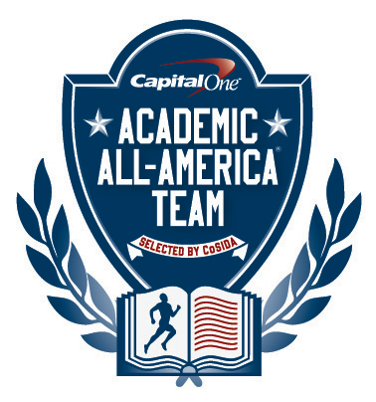

Capital One Academic All-America® Team

Selected by CoSIDA
FOR RELEASE: Monday, August 5, 2013 – 12 noon (EDT)

Please visit the Capital One Academic All-America® website http://www.capitaloneacademicallamerica.com/

SOCCER STANDOUT MIA PERSSON OF LINDSEY WILSON
NAMED AS CAPITAL ONE COLLEGE DIVISION
ACADEMIC ALL-AMERICA® OF THE YEAR

TOWSON, Md. – Senior midfielder Mia Persson, who led the Lindsey Wilson women’s soccer team to the NAIA national championship, has been named as the 2012-13 Capital One College Division Academic All-America® of the Year, as selected by the College Sports Information Directors of America (CoSIDA).
The College Division Academic All-America® teams are comprised of student-athletes from NAIA, Canadian and two-year institutions. This is the second year that CoSIDA and Capital One have named College Division Academic All-America® teams. Persson is the second scholar-athlete to earn the Capital One College Division Academic All-America® of the Year award.
A communication major who graduated with a 3.92 G.P.A., Persson had a perfect 4.00 G.P.A. in her senior year. She led the Blue Raiders to a 20-4-1 record and the NAIA championship. Lindsey Wilson edged Olivet Nazarene in the championship game, 3-2.
Persson was named as the NAIA Tournament’s Most Valuable Player award after scoring five goals with one assist in five tournament games. A native of Sjobo, Sweden, she also earned the NAIA Tournament of Champions of Character award.
A four-time NAIA All-American, she was a first team selection as a junior and senior. She earned third team honors as a sophomore and was a second team pick as a freshman. She finished her career with a school record 72 goals and 170 career points.
As a senior, she tallied 31 goals with six assists and was named as the NAIA Women’s Soccer Player of the Year. She was also honored as the Mid-South Conference Player of the Year for the second straight season.
Named as an NAIA Scholar-Athlete in 2012 and 2011, Persson was named as to the Mid-South Academic All-Conference team three times.
In her career, she led Coach Drew Burwash’s team to four straight conference championships and a 74-15-5 overall record.
On Tuesday, August 6, the Capital One Division III Academic All-America® of the Year award winner will be announced. On Wednesday, August 7, the Capital One Division II Academic All-America® of the Year award winner will be announced. The Capital One Division I Academic All-America® of the Year award winner will be named on Thursday, August 8.
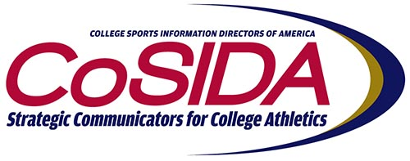

About Capital One
Capital One Financial Corporation (www.capitalone.com) is a financial holding company whose subsidiaries, which include Capital One, N.A. and Capital One Bank (USA), N. A., had $216.5 billion in deposits and $294.5 billion in total assets outstanding as of March 31, 2012. Headquartered in McLean, Virginia, Capital One and ING Direct offer a broad spectrum of financial products and services to consumers, small businesses and commercial clients through a variety of channels. Capital One, N.A. has approximately 1,000 branch locations primarily in New York, New Jersey, Texas, Louisiana, Maryland, Virginia and the District of Columbia.
A Fortune 500 company, Capital One trades on the New York Stock Exchange under the symbol "COF" and is included in the S&P 100 index.
Capital One, an NCAA Corporate Champion, began its affiliation with college sports with the sponsorship of the 2001 Capital One Florida Citrus Bowl (now the Capital One Bowl) and ESPN’s Capital One Bowl Week. In addition, Capital One sponsors the ABC College Football Halftime Report, Capital One All-America Mascot team, Capital One Academic All Program, and supports all 89 NCAA Championships including the Division I Men’s and Women’s Basketball Championships, and numerous other collegiate athletics programs.
To be eligible for Academic All-America® consideration, a student-athlete must be a varsity starter or key reserve, maintain a cumulative G.P.A. of 3.30 on a scale of 4.00, have reached sophomore athletic and academic standings at his/her current institution and be nominated by his/her sports information director.
Since the program’s inception in 1952, CoSIDA has bestowed Academic All-America honors on more than 20,000 student-athletes in Divisions I, II, III and NAIA, covering all NCAA championship sports.
For more information about the Academic All-America® Teams program, please visit www.cosida.com.

2012-2013 CAPITAL ONE SPORT-BY-SPORT COLLEGE DIVISION ACADEMIC ALL-AMERICA® OF THE YEAR AWARD WINNERS
Name Sport Cl. Hometown Major, G.P.A.
Ashlan Allison, Olivet Nazarene W. At-Large Sr. Anderson, Ind. Social Work, 4.00
*Liam Barrett, Illinois Institute of Tech. M. Soccer Sr. Felixstowe, England Business, 4.00
* Paula Ferreira, Columbia (Mo.) Volleyball Sr. Rio de Janeiro, Brazil International Business, 3.89
Hollie German, Lee University W. Basketball Jr. Benton, Tenn. Mathematics/Sec. Education, 3.98
Brad Karp, Saint Xavier M. Basketball Jr. Valparaiso, Ind. Biology, 3.61
* Monte Larsen, Morningside M. Track, CC Gr. Neola, Iowa Master of Arts in Teaching, 4.00
Breanna Mathes, Morningside W. Track, CC Sr. Cherokee, Iowa Mathematics Teaching, 3.99
Emma Napier, Campbellsville Softball Sr. Scottsville, Ky. Business, 3.93
Mia Persson, Lindsey Wilson W. Soccer Sr. Sjobo, Sweden Communication, 3.89
Nicolas Pinones-Haltenhoff, Auburn-M M. At-Large So. Barcelona, Spain Biology, 4.00
* Jake Snodgrass, McPherson Football Sr. Derby, Kan. Biology, 3.89
Alan Spanel, Doane College Baseball Sr. Norfolk, Neb. Biochemistry, 4.00

* repeat selections
FOR MORE INFORMATION:
Dan O’Connell, Towson University (doconnell@towson.edu) (410) 704-3102
Academic All-America ® Vice-Chair for Publicity/Communications

